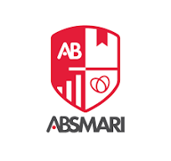
Abhinav Bindra Sports Medicine and Research Institute
BPT 1st Year 2ND Semester 1ST Internal Examination

Date: 08.07.2025 Subject: PHYSIOLOGY
Time: 9:00 – 11:00 AM F.M. - 40

A) LONG QUESTIONS – Answer any 2 (2 X 10)

- Describe Cardiac Cycle in brief
- Write down structure and function of skin
- Describe mechanism of Respiration
B) SHORT QUESTIONS- Answer any 3 (3 X 5)
1.Motor Unit
2.Visual Pathway
3.Stretch Reflex
4.Heart Sounds
C) OBJECTIVE TYPE QUESTION (1 x 5)
1. Function of Pituitary Gland
2.What is the primary function of Respiratory
3.Which type of muscle is responsible for Voluntary movement
4. Primary function of Adrenal Gland
5.The process of blood cell formation is called

