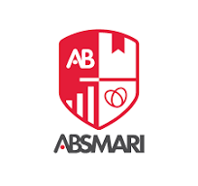
Abhinav Bindra Sports Medicine and Research Institute
BPT 2nd Semester 1st Internal Examination

Date: 07/072025 Subject: Human Anatomy
Time: 09:00 – 12:00 AM F.M. – 80

A) LONG QUESTIONS – Answer any 3 (3 X 15)

- What is joint? Discuss about different types of joint of human body?
- Discuss about structure, blood supply and development of right atrium of heart?
- Describe the brachial plexus under following heading: Route, trunk devision, course, cord? Discuss erb point and clinical significance?
- Discuss about knee joint? Describe the locking and unlocking mechanism of knee joint?
B) SHORT QUESTIONS- Answer any 6 (6 X 5)
- Deltoid muscle
- Facial nerve
- femoral sheath
- Popliteal fossa
- Cartilage
- blood supply of spinal cord

C) OBJECTIVE TYPE QUESTION (1 x 5)
- Radio ulnar joint is a synovial variety of which joint?
- What is ostomy?
- Sub acromion bursa present in which joint?
- Periosteal artery supply which area of bones?
- Give a example of syndesmosis type of joint?

*******

